**Public Key Infrastructure (PKI) Lab**

|  |  |  |
| --- | --- | --- |
| **Title** | **Author** | **Date** |
| Public Key Infrastructure(PKI) Lab | M.Umer Hassan | 01-01-2022 |

**Task 1:** **Becoming a Certificate Authority (CA)**

Copy the configuration file into current directory:

*cp /usr/lib/ssl/openssl.cnf ./openssl.cnf*

create new sub-directories and files according to what it specifies in its **[ CA_default ]** section:

*dir = ./demoCA # Where everything is kept*

*certs = $dir/certs # Where the issued certs are kept*

*crl_dir = $dir/crl # Where the issued crl are kept*

*new_certs_dir = $dir/newcerts # default place for new certs.*

*database = $dir/index.txt # database index file.*

*serial = $dir/serial # The current serial number*

Simply create an empty file for **index.txt**, put a single number in string format in serial:

*mkdir ./demoCA*

*cd ./demoCA*

*mkdir certs*

*mkdir crl*

*mkdir newcerts*

*touch index.txt*

*echo "1000" > serial*

Start to generate the self-signed certificate for the CA:

*# return to the parent directory*

*# cd ..*

openssl req -new -x509 -keyout ca.key -out ca.crt -config openssl.cnf

Notice that we apply policy_match in openssl.cnf, so we should keep some fields the same when creating certificates for CA and servers:

*[ policy_match ]*

*countryName = match*

*stateOrProvinceName = match*

*organizationName = match*

*organizationalUnitName = optional*

*commonName = supplied*

*emailAddress = optional*

When asked to type PEM pass phrase, remember the password you typed (e.g. I use 114514). It will then ask you to fill in some information, you can skip it by **Enter**, except for those required by **policy_match**.

The output of the command are stored in two files: **ca.key** and **ca.crt**. The file ca.key contains the CA’s **private key**, while ca.crt contains the **public-key certificate**.

**Task 2: Creating a Certificate for SEEDPKILab2018.com**

As a root CA, we are ready to sign a digital certificate for **SEEDPKILab2020.com**.

**Step 1: Generate public/private key pair**

Generate an RSA key pair. Provide a pass phrase (e.g. I use **soudayo**) to encrypt the private key in **server.key** using AES-128 encryption algorithm.

*openssl genrsa -aes128 -out server.key 1024*

To see the actual content in server.key (pass phrase required):

*openssl rsa -in server.key -text*

**Step 2: Generate a Certificate Signing Request (CSR)**

Use **SEEDPKILab2020.com** as the common name of the certificate request

*openssl req -new -key server.key -out server.csr -config openssl.cnf*

Skip the unnecessary information as well, keep the necessary information (required by **policy_match** consistent with the **CA.crt** created in [Task 1](https://github.com/li-xin-yi/seedlab/tree/master/PKI#task-1)).

Now, the new Certificate Signing Request is saved in **server.csr**, which basically includes the company's public key.

*The CSR will be sent to the CA, who will generate a certificate for the key (usually after ensuring that identity information in the CSR matches with the server's true identity)*

**Step 3: Generating Certificates**

In this lab, we will use our own trusted CA to generate certificates.

Use **ca.crt** and **ca.key** to convert server.csr to server.crt:

*openssl ca -in server.csr -out server.crt -cert ca.crt -config openssl.cnf*

**Task 3: Deploying Certificate in an HTTPS Web Server**

**Step 1: Configuring DNS**

Open and edit **/etc/hosts**:

*sudo gedit /etc/hosts*

Add one line:

*127.0.0.1 SEEDPKILab2018.com*

**Step 2: Configuring the web server**

Combine the secret key and certificate into one single file **server.pem**:

*cp server.key server.pem*

*cat server.crt >> server.pem*

Launch the web server using **server.pem**:

*openssl s_server -cert server.pem -www*

Now, the server is listening on port 4433. Browser <https://seedpkilab2018.com:4433/>

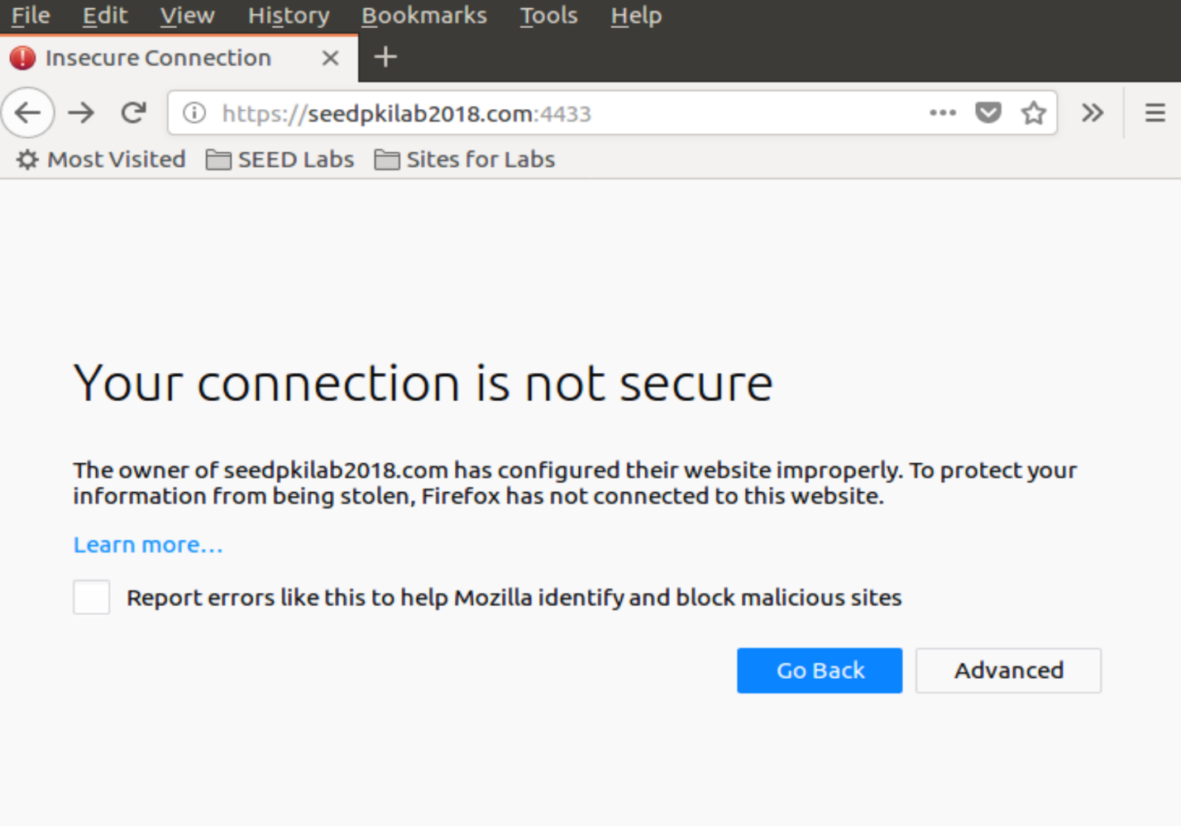

**Step 3: Getting the browser to accept our CA certificate.**

Search for "certificate" in Firefox's Preferences page, click on "View Certificates" and enter "certificate manager", click on "Authorities tab" and import CA.crt. Check "Trust this CA to identify web sites".

Reload <https://seedpkilab2018.com:4433/>.

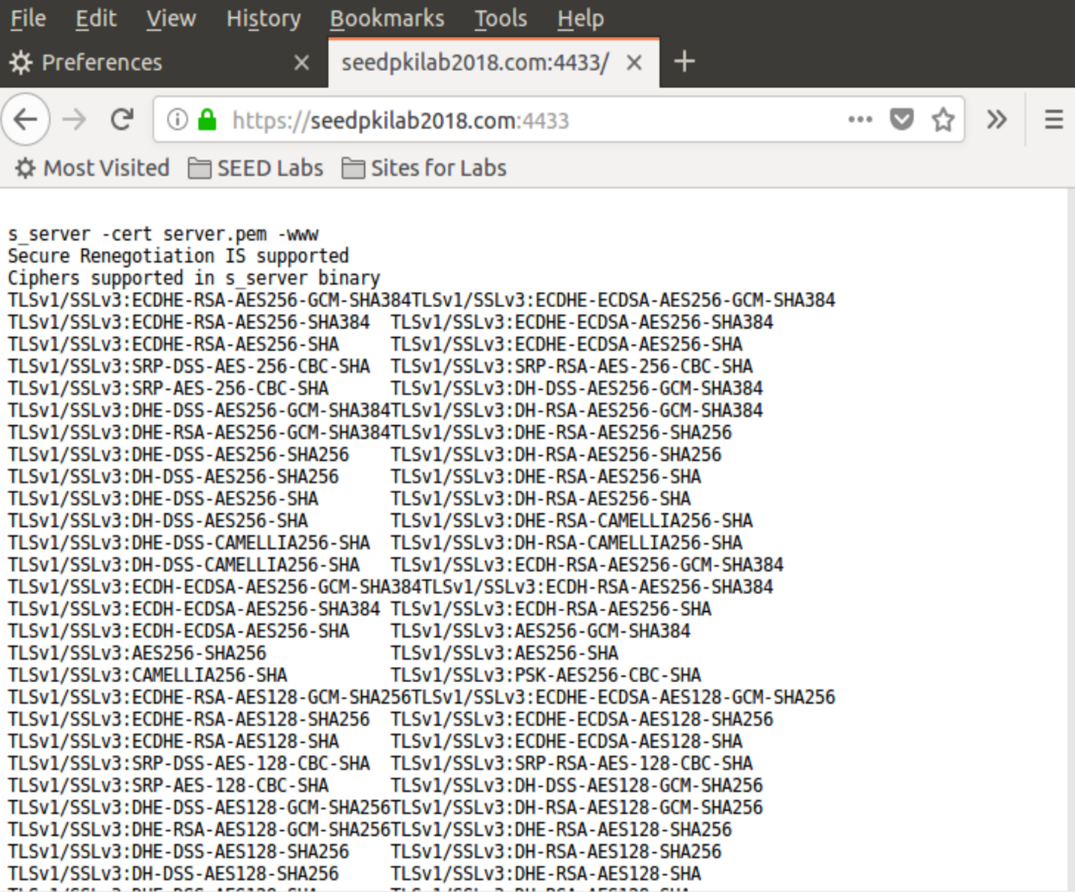

**Step 4. Testing our HTTPS website**

**Modify one byte in server.pem**

It's up to which byte you modify. Most bytes make no differences after corrupted. But some will make the certificate invalid.

**Use localhost**

When browsing https://localhost:4433, it is reported unsafe HTTPS

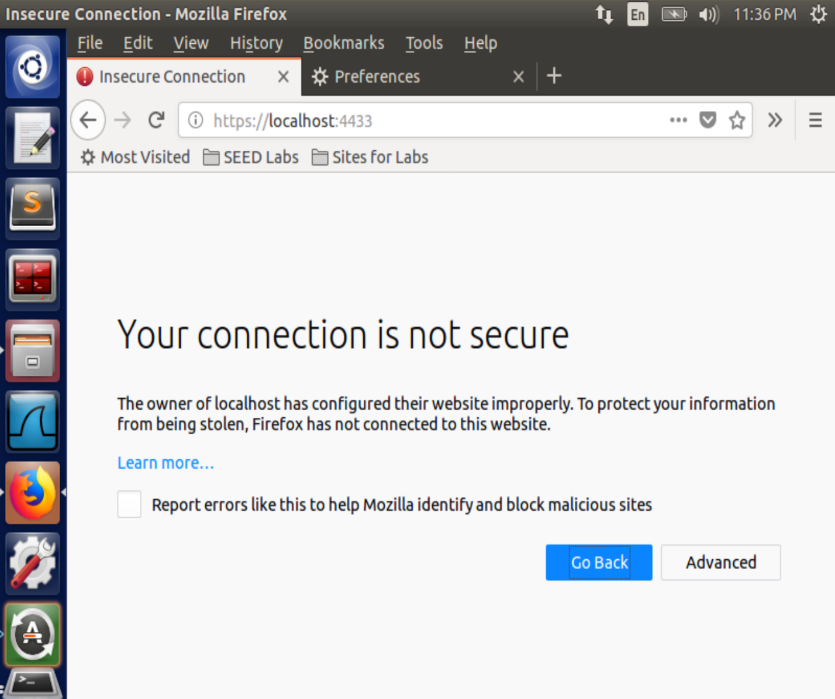

Because the locolhost has no certificate, the website is using a certificate identified for seedpkilab2018.com.

**Task 4: Deploying Certificate in an Apache-Based HTTPS Website**

Open configuration file of Apache HTTPS server:

*sudo gedit /etc/apache2/sites-available/default-ssl.conf*

Add the entry and save:

*<VirtualHost *:443>*

*ServerName SEEDPKILab2018.com*

*DocumentRoot /var/www/pki*

*DirectoryIndex index.html*

*SSLEngine On*

*SSLCertificateFile /var/www/pki/server.crt*

*SSLCertificateKeyFile /var/www/pki/server.pem*

*</VirtualHost>*

Copy the server certificate and private key to the folder:

*sudo mkdir /var/www/pki*

*sudo cp server.pem server.crt /var/www/pki*

Test the Apache configuration file for errors:

*sudo apachectl configtest*

Enable the SSL module:

*sudo a2enmod ssl*

Enable the site we have just edited:

*sudo a2ensite default-ssl*

Restart **Apache**:

*sudo service apache2 restart*

Once Apache runs properly, open <https://seedpkilab2018.com/>

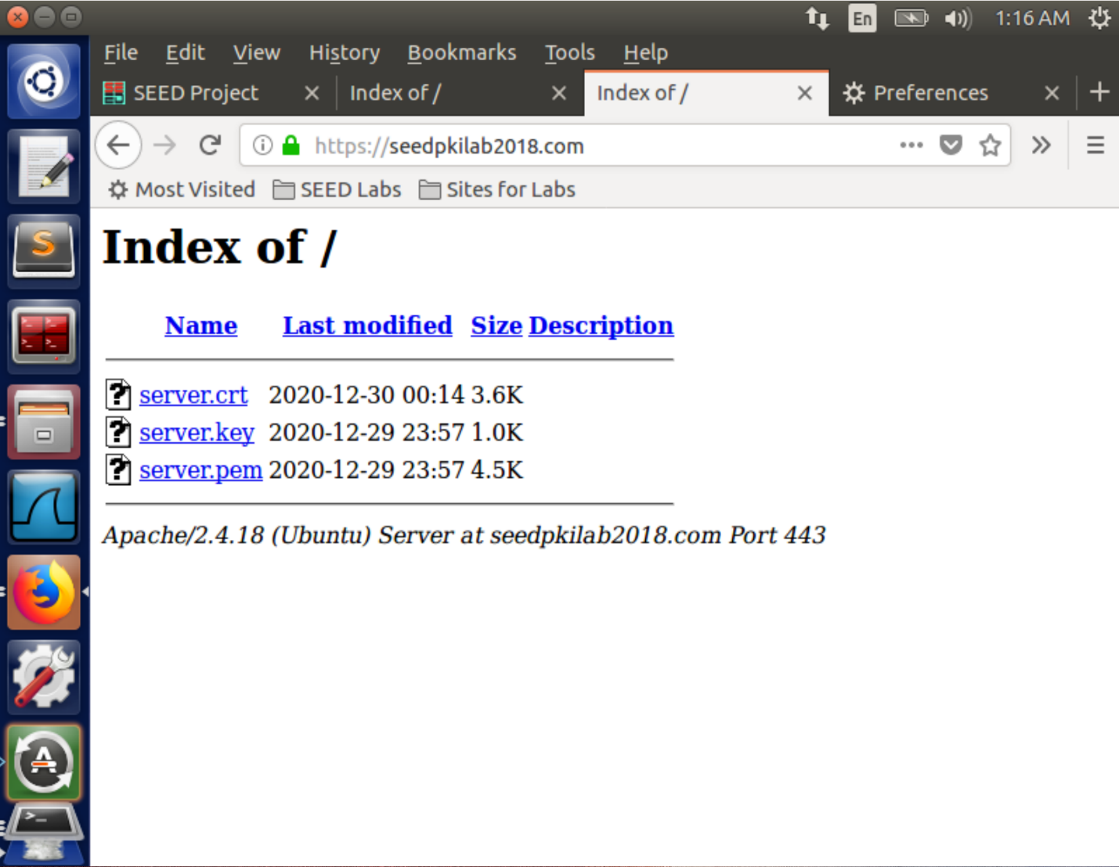

**Task 5: Launching a Man-In-The-Middle Attack**

Suppose we still use this VM (**10.0.2.10**) as the malicious server, start another VM (**10.0.2.4**) as the victim.

**Generate a certificate for example.com**

use a password (e.g. I use **islander**):

*openssl genrsa -aes128 -out example.key 1024*

Use **example.com** as the common name of the certificate request:

*openssl req -new -key example.key -out example.csr -config openssl.cnf*

*openssl ca -in example.csr -out example.crt -cert ca.crt -keyfile ca.key *

*-config openssl.cnf*

*cp example.key example.pem*

*cat example.crt >> example.pem*

Copy the certificate and private key to the website root folder:

*sudo mkdir /var/www/example*

*sudo cp example.crt example.pem /var/www/example*

Config and start the server

On the server VM, open **/etc/apache2/sites-available/default-ssl.conf** and add the following entry:

*<VirtualHost *:443>*

*ServerName example.com*

*DocumentRoot /var/www/example*

*DirectoryIndex index.html*

*SSLEngine On*

*SSLCertificateFile /var/www/example/example.crt*

*SSLCertificateKeyFile /var/www/example/example.pem*

*</VirtualHost>*

Restart **Apache**:

*sudo apachectl configtest*

*sudo service apache2 restart*

**Config on Victim VM**

On the victim VM, modify **/etc/hosts** by:

*sudo gedit /etc/hosts*

add one line before the ending, which emulates a DNS cache positing attack:

*10.0.2.10 example.com*

To get the **ca.crt**, listen on a local port like:

*nc -lvp 4444 > ca.crt*

Then on the server VM, we send **ca.crt** by:

*cat ca.crt | nc 10.0.2.4 4444*

Once we receive the file on the victim VM, we install it on Firefox as **above**.

Now, when browsing https://example.com/, the user on this VM actually visit the fake website launched by the malicious server:

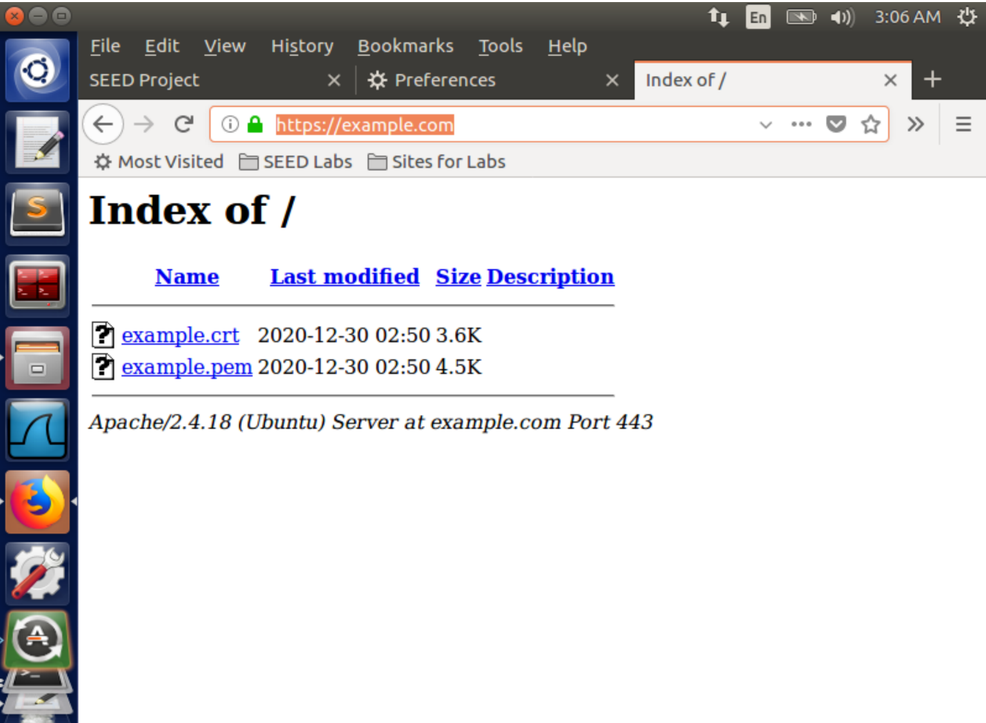

**Task 6: Launching a Man-In-The-Middle Attack with a Compromised CA**

Based on Task 5, we can assume if the attacker stole **ca.key**, which indicates that he/she can easily generate the CA certificate **ca.crt** by the compromised key:

*openssl req -new -x509 -keyout ca.key -out ca.crt -config openssl.cnf*

Then, ca.crt can be used to sign any server's certificate, including the forged ones. The process of such attacks can be described as what we did before, except that we don't even need to deploy the ca.crt on the victim machine because it has already installed the same ca.crt.